**Windows EC2 & VPC: The Hotdogs Cafe Digital Transformation**

**Project Description:**

**"Windows EC2 & VPC: The Hotdogs Cafe Digital Transformation"** leverages AWS technology to revolutionize the Hotdogs Cafe's online presence. By utilizing AWS EC2 Windows instances and Virtual Private Cloud (VPC), the project ensures a robust, scalable, and secure web hosting environment. This transformation enhances the cafe's digital footprint, providing a seamless user experience and reliable performance. The integration of these services supports efficient management, improved accessibility, and optimal security for the cafe’s online operations. This initiative aims to drive business growth by modernizing the cafe’s digital infrastructure."

**Scenario 1: Enhanced Customer Engagement:**

With the new AWS EC2 Windows and VPC setup, Hotdogs Cafe can provide a more responsive and reliable website experience. This leads to better user engagement, as customers experience faster load times and uninterrupted service. As a result, the cafe can attract more online visitors, drive higher traffic to its website, and increase online orders and reservations.

**Scenario 2: Scalable Growth Opportunities:**

The implementation of AWS EC2 Windows instances and VPC allows Hotdogs Cafe to easily scale its web infrastructure as its business grows. Whether the cafe launches new promotions, expands its menu, or opens additional locations, the cloud-based setup can accommodate increased traffic and operational demands without requiring significant additional investment in physical hardware.

**Scenario 3: Improved Security and Compliance:**

By utilizing AWS VPC and Windows EC2, Hotdogs Cafe benefits from enhanced security features that protect sensitive customer data and ensure compliance with industry regulations. This minimizes the risk of data breaches and ensures that customer information is handled securely. A secure and compliant digital environment builds customer trust and reinforces the cafe's reputation as a reliable and responsible business.

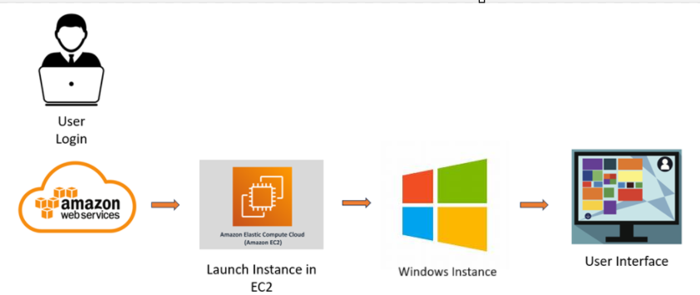

**Pre-requisites:**

### 1. AWS Account Setup: [https://youtu.be/CjKhQoYeR4Q?si=ui8Bvk_M4FfVM-D](https://youtu.be/CjKhQoYeR4Q?si=ui8Bvk_M4FfVM-Dh)h

### 2. Understanding of IAM: <https://youtu.be/gsgdAyGhV0o?si=3qg-bULgkD4LXNvR>

### 3. Knowledge of Amazon EC2 :<https://youtu.be/8TlukLu11Yo?si=MUj0nEAOESRhHUIz>

**Project Flow:**

**Project Initialization:**

* Define objectives, scope, and KPIs for deploying the Hotdogs Cafe website.
* Set up AWS environment, including EC2 instance configuration and MobaXterm setup.

**EC2 Instance Creation:**

* Launch an EC2 instance to host the Hotdogs Cafe website.
* Select the appropriate instance type based on resource requirements.

**MobaXterm Configuration:**

* Install and configure MobaXterm for remote access to the EC2 instance.
* Set up SSH keys and configure session settings for seamless connection.

**Website Deployment:**

* Replace the Default website in the windows webserver with Hotdogs Café Website files.
* Configure the web server settings in windows Instance to serve the Hotdogs Café website.

**Testing and Optimization:**

* Test the website for functionality, performance, and security.
* Optimize server settings and website configurations for better performance.

**Monitoring and Maintenance:**

* Implement monitoring tools to track website performance and uptime.
* Regularly update and maintain the website and server to ensure reliability.

**Milestone 1: Create an AWS account and login to console**

In this milestone, we will create and signin to the aws console.

**Activity 1.1 : Create AWS Account**

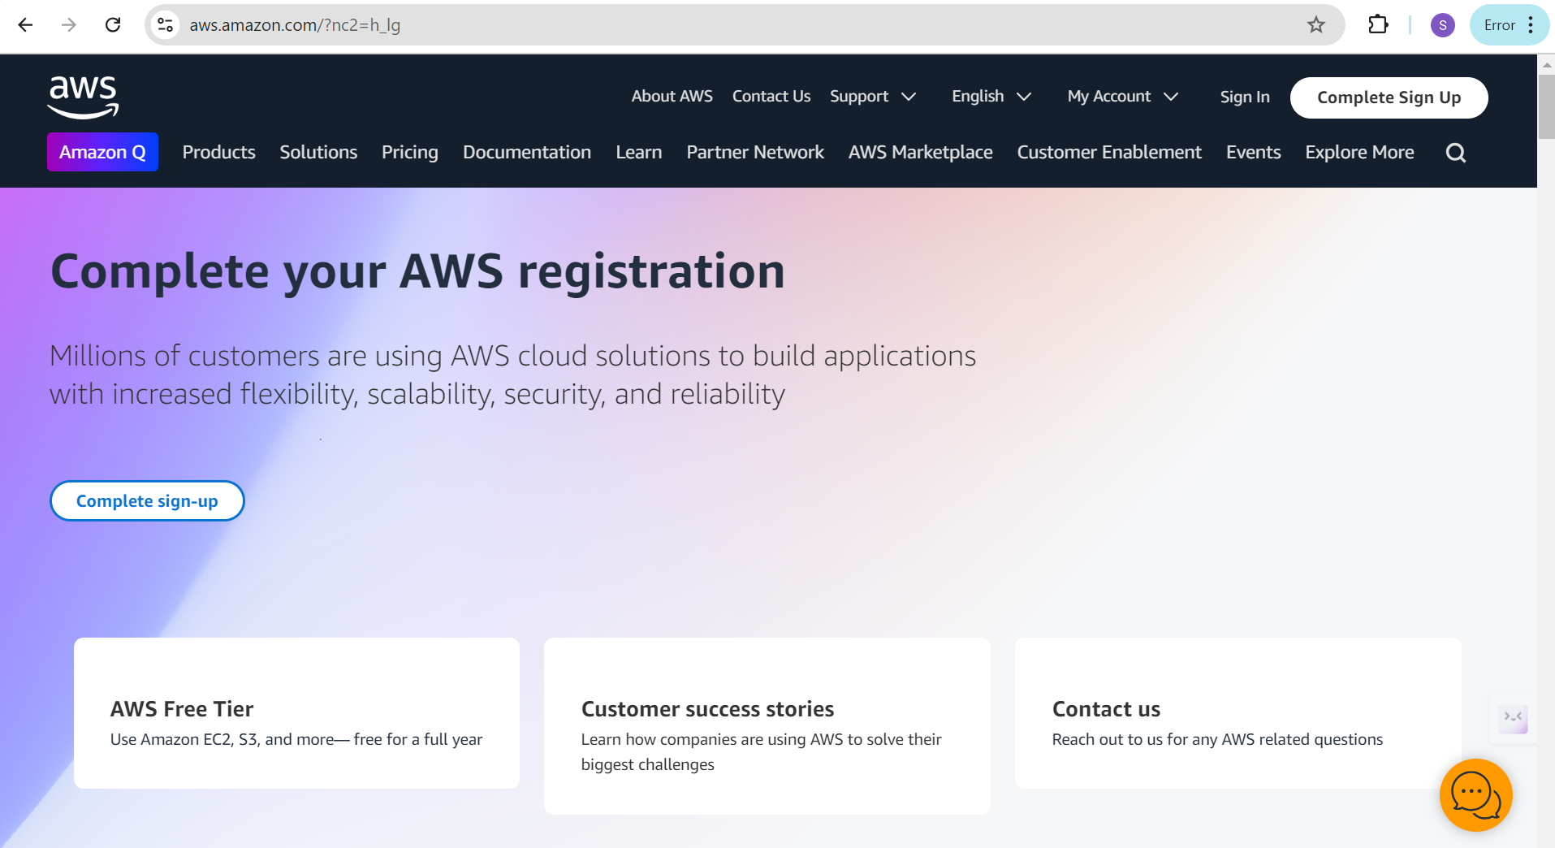

**Activity 1.2 : Log in to AWS Management Console:**

Access the AWS Management Console using your credentials.

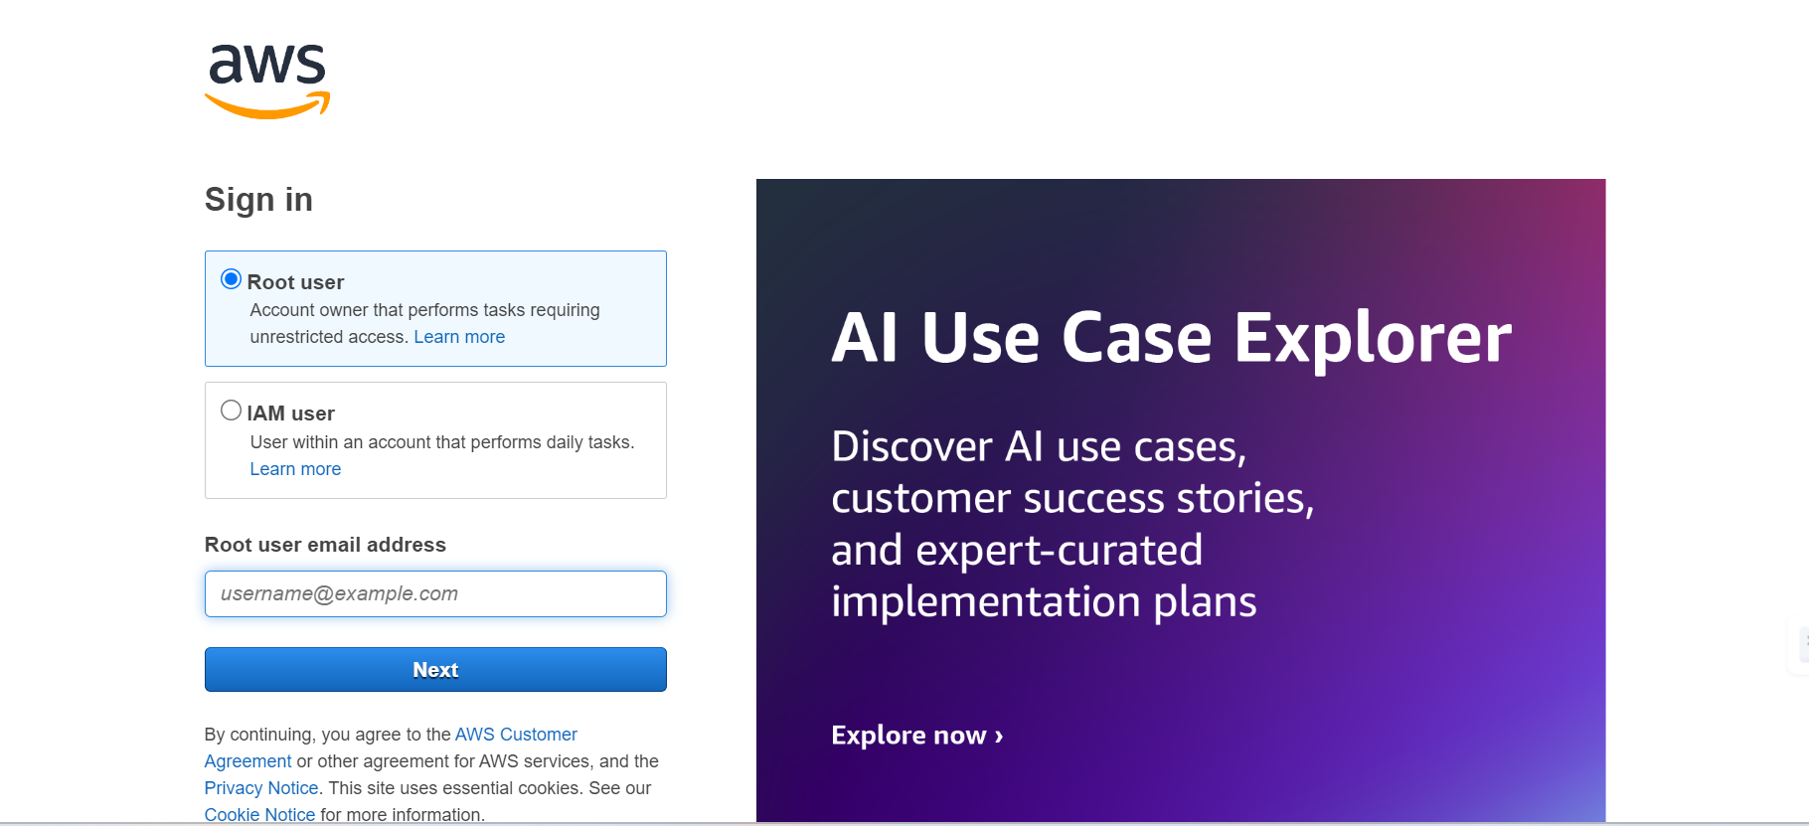

### Milestone 2 : Setting Up AWS EC2 Instance

In this Milestone welaunch and configure an EC2 instance to host the website. This step involves creating an EC2 instance that will serve as the server environment for the website.

**Activity 2.1 : Creating EC2 instance**

* Search for EC2 in navigation bar
* Click on Ec2

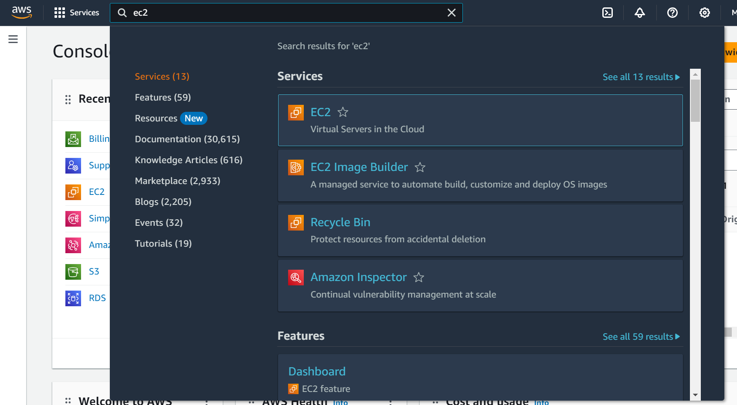

* In the EC2 Dashboard click on Launch Instance

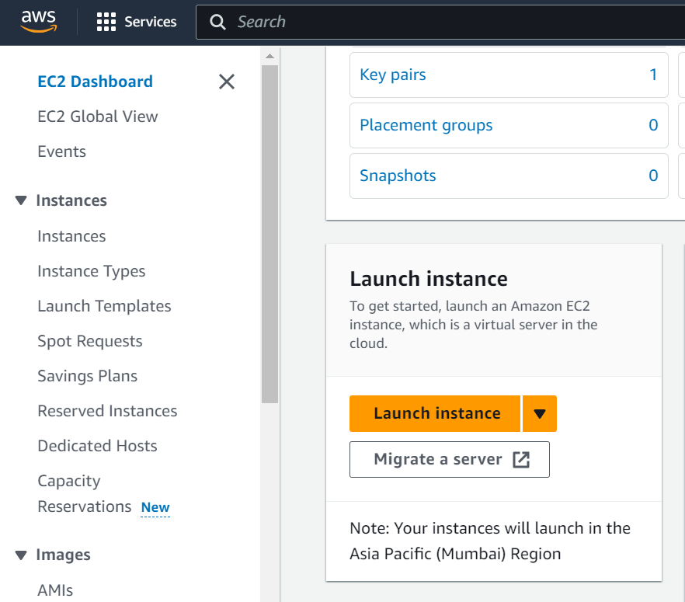

* Click on "Launch Instance" to start the instance creation wizard.
* Choose an Amazon Machine Image (AMI) suitable for your application (e.g., Amazon Linux 2 or Ubuntu).
* Select an instance type (e.g., t2.micro for testing or t3.medium for production).
* Configure instance details, including network settings and storage options.
* Create or select an existing key pair for secure SSH access.

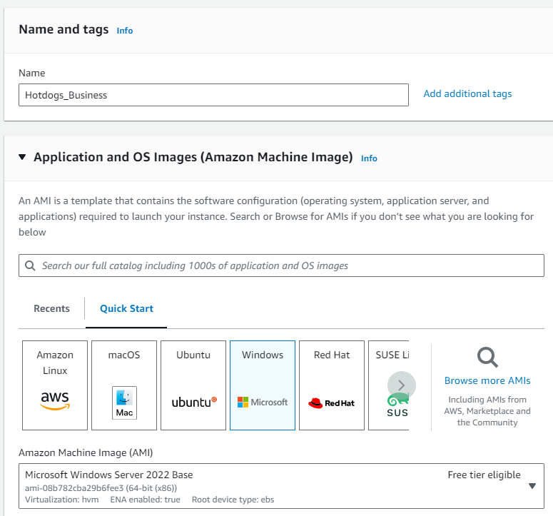

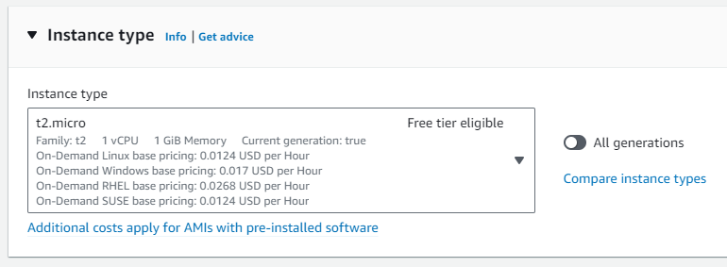

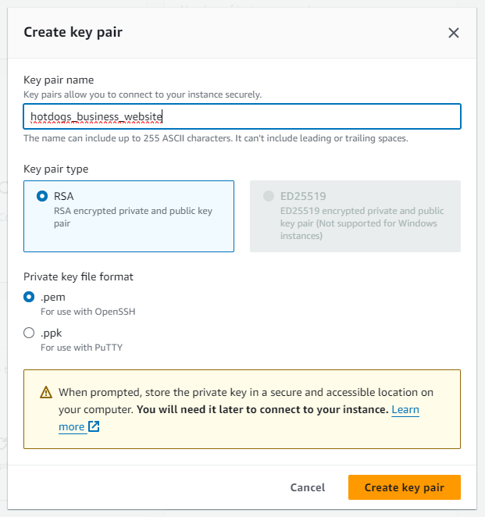

**Activity 2.2: Storing the key pair as .pem file**

* Create a key pair and keep the .pem file in the local system.

**Activity 2.3 : Network settings**

* Allow SSH Traffic from anywhere
* Launch instance

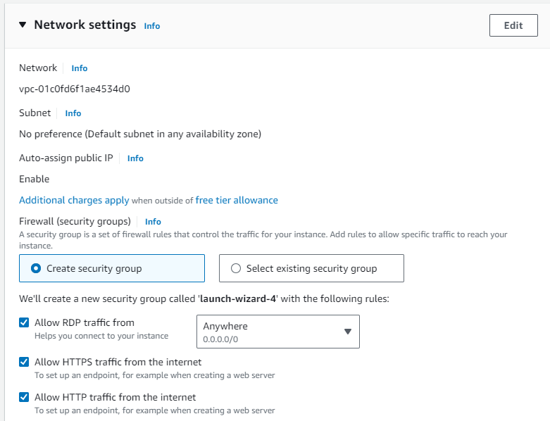

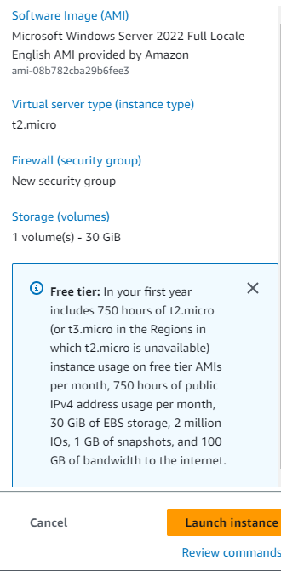 

* Review and launch the instance, then wait for the instance status to change to "Running."

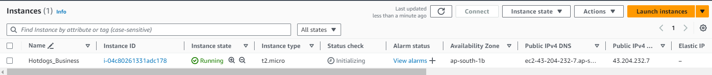

**Activity 2.5 : Setting up Inbound and Outbound rules**

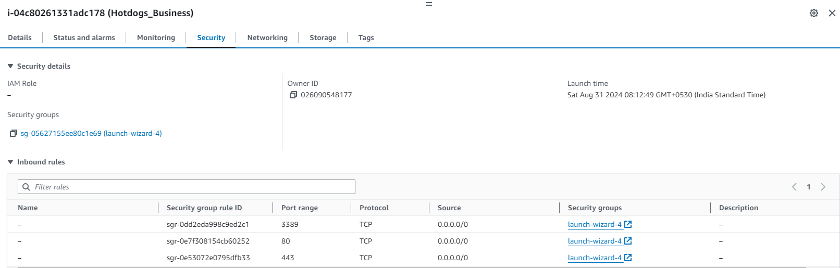

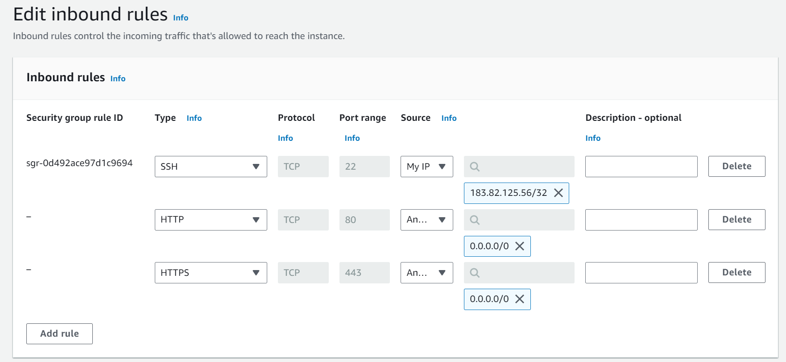

* Add Type : HTTP > Source : Anywhere
* Add Type : HTTPS > Source : Anywhere

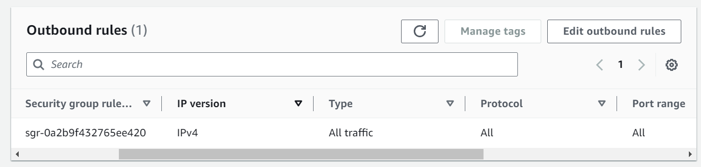

### Milestone 3: Connect the Instance.

In this milestone we connect the Instance by downloading the RDP file and passwords. By using this password and .rdp file we can going to connect the windows instance. A saperate Microsoft windows with choosen specifications for free tire will be allorted.

**Activity 3.1 :**

* Click on connect to connect the instance
* Download .rdp file and create a password.
* Open MobaXterm and create a new SSH session.



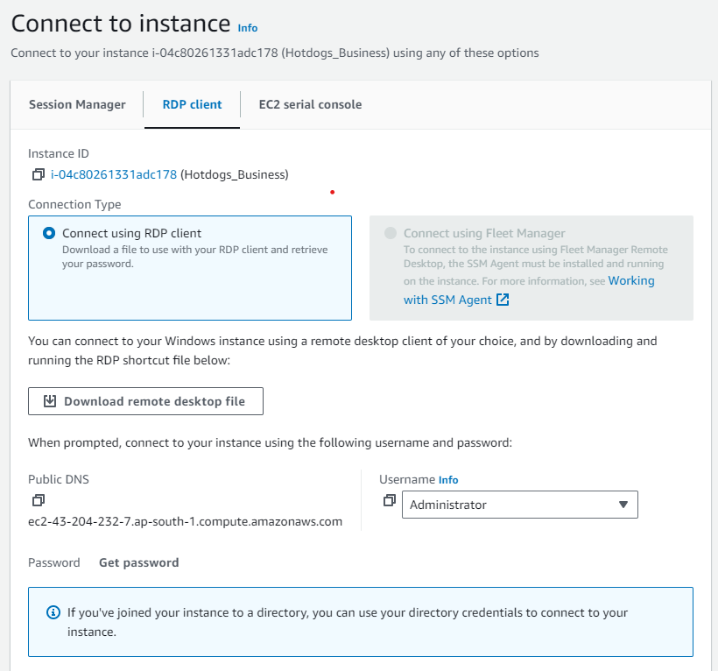

* Click on Download remote desktop file and simultaneously click on get password.

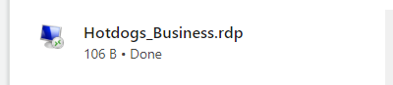

Above file will be downloaded by click on the “Download Desktop files”.

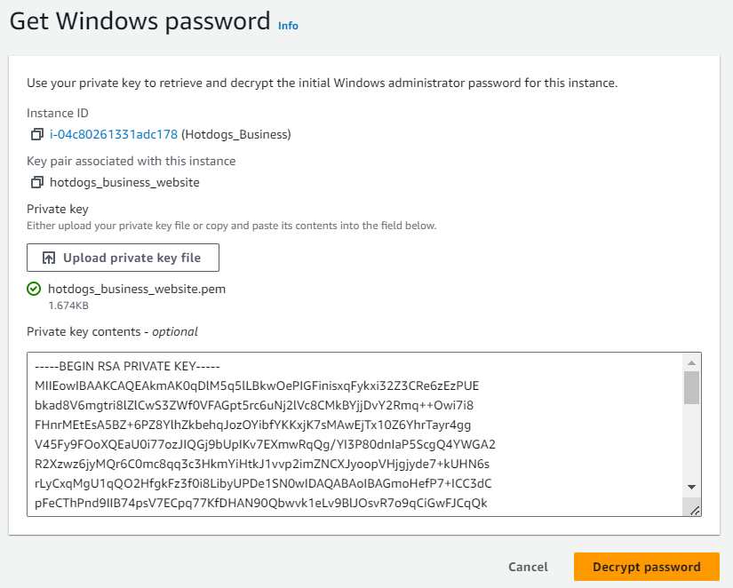

Upload the primay key file downloaded previously and click on decrypt password to get the actual password for accessing mote desktop file.

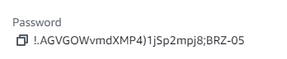

Password obtained after Decrypting the pem file. Copy the password.

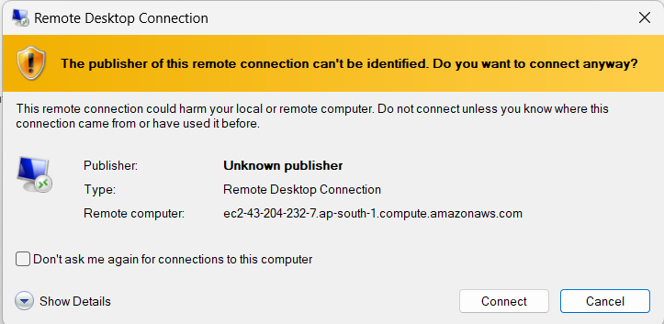

Click on connect to connect the remote Desktop connection.

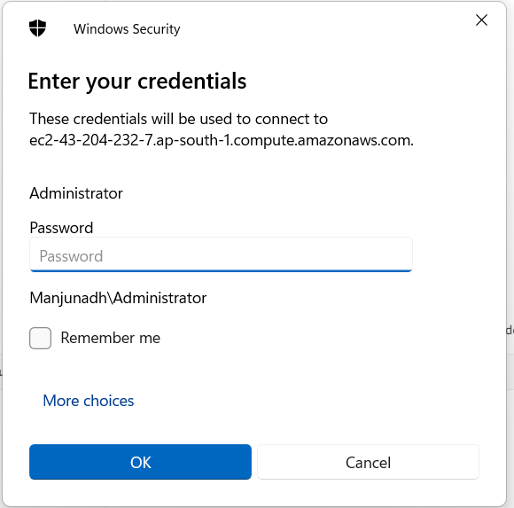

Paste the Copied password here and Click ok

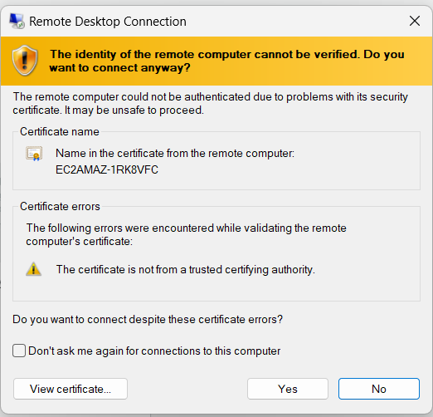

Click Yes to get into the remote desktop connection

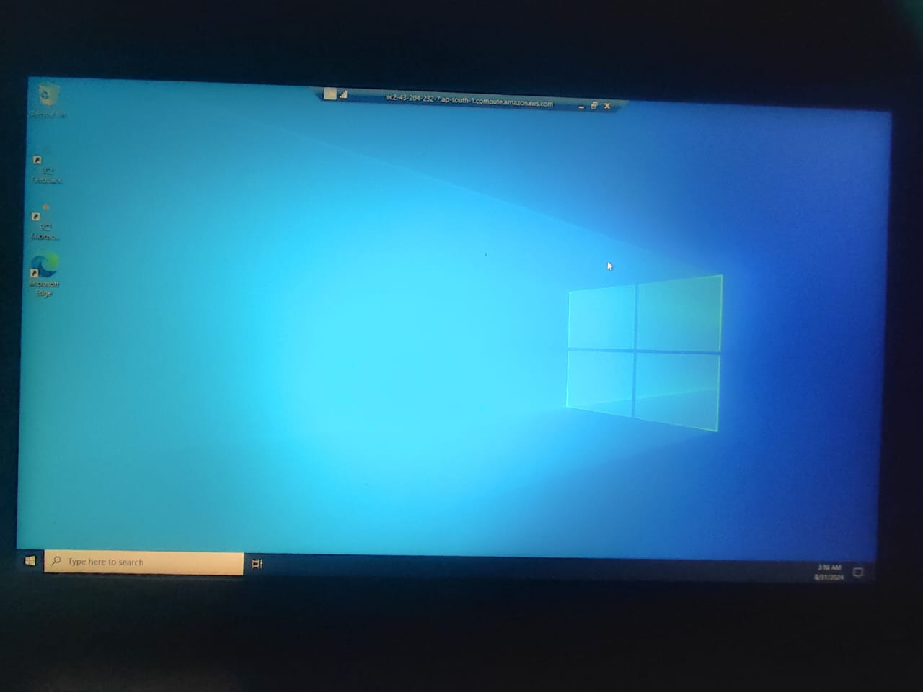

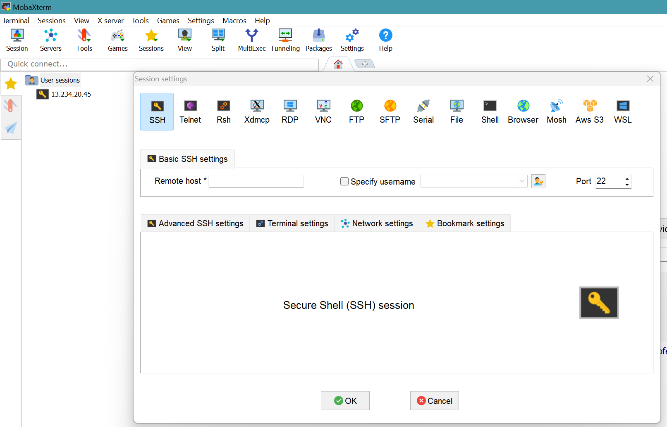

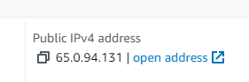

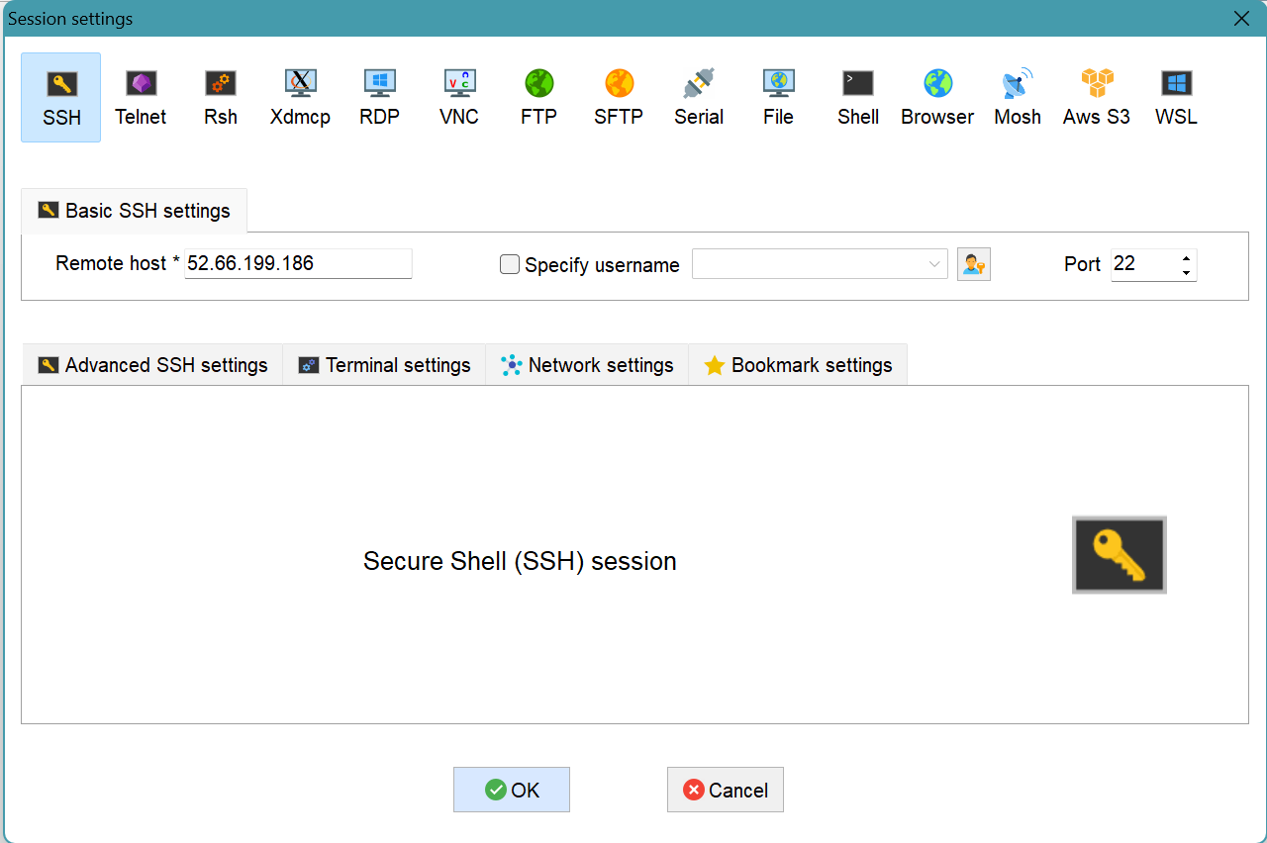

* Click on Advanced settings and Upload the .pem file into it



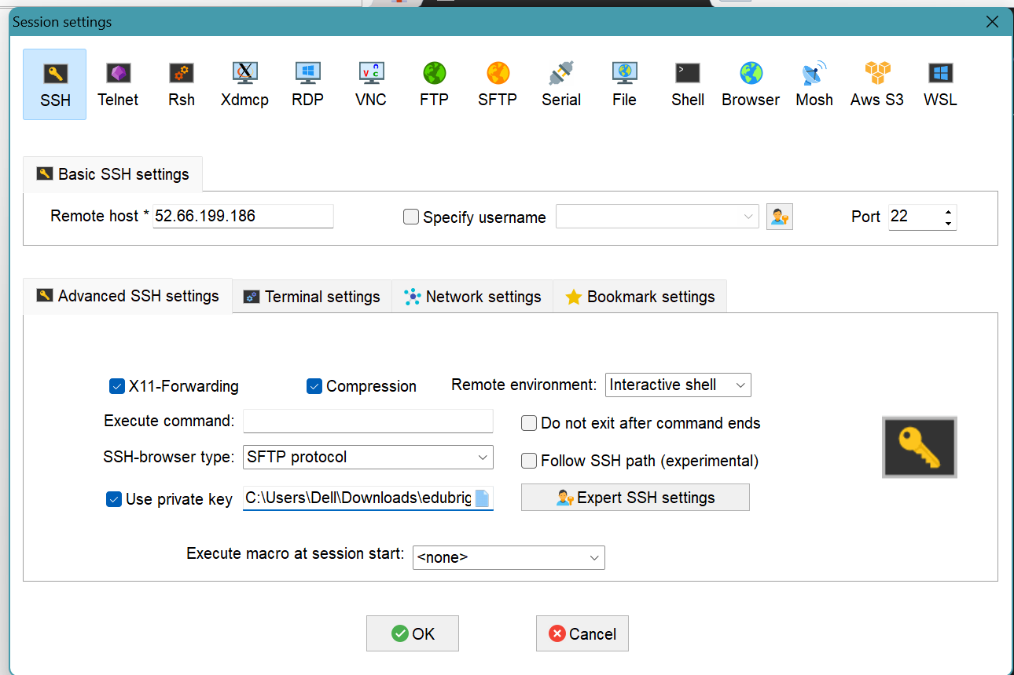

* Accept the check box

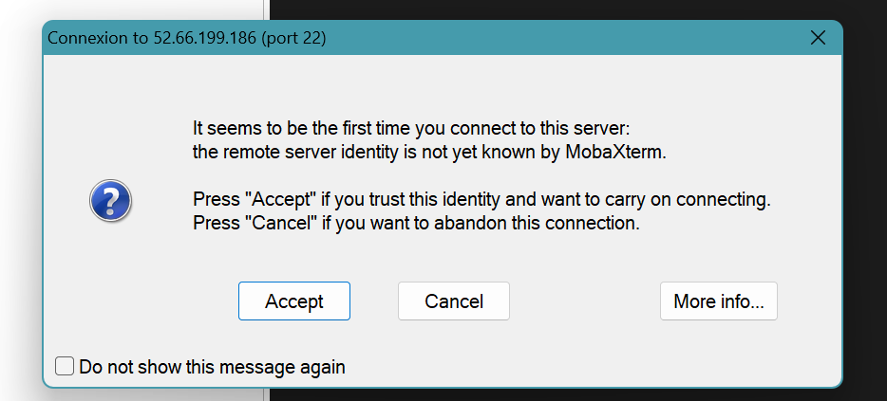

**Milestone 4: Configure Web Server on EC2**

In this Milestone, we set up a web server environment on the EC2 instance to serve the EduBridge website. This includes installing necessary software and configuring the server.

**Activity 4.1: Login into the SSH Session**

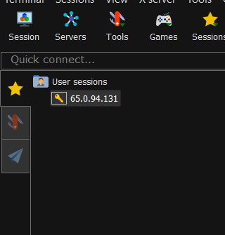

* Login as : ec2-user

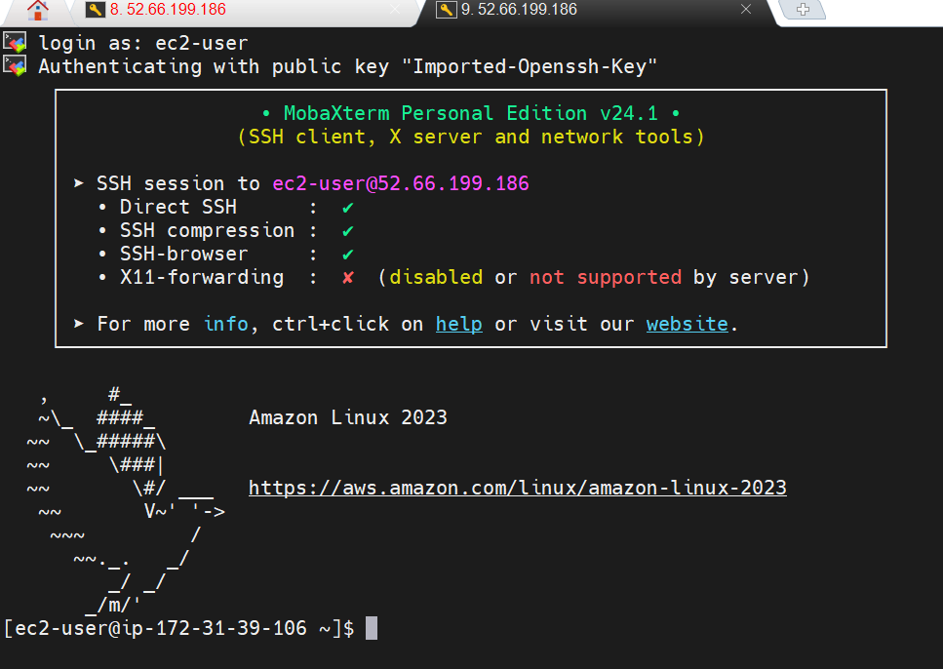

**Activity 4.2: Update and Install Web Server Software**

* Update package lists with sudo apt-get update (Ubuntu) or sudo yum update (Amazon Linux).

Install Apache or Nginx:

* For Apache: sudo apt-get install apache2 (Ubuntu) or sudo yum install httpd (Amazon Linux).
* For Nginx: sudo apt-get install nginx (Ubuntu) or sudo yum install nginx (Amazon Linux).

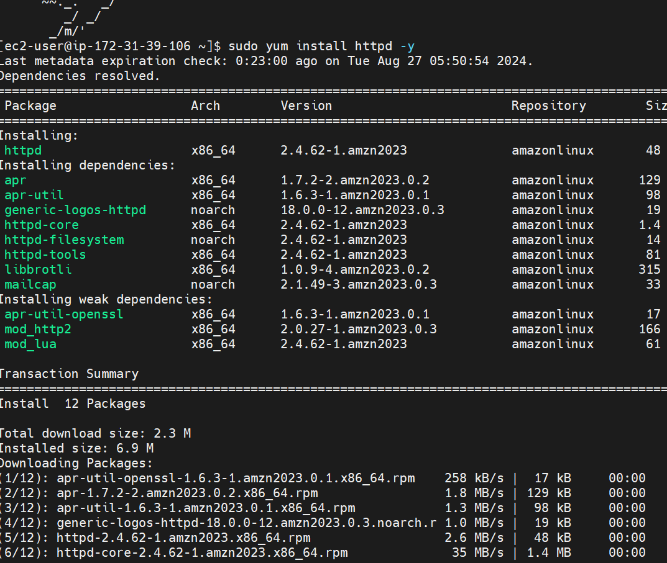

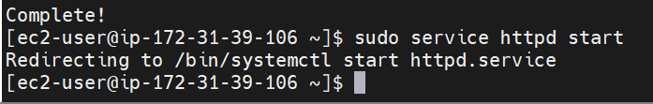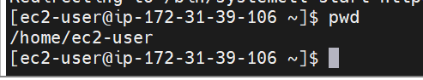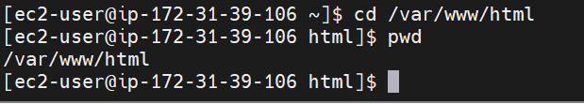

### Milestone 5 : Deploy EduBridge Website Code

### In this milestone we upload and deploy the website code to the web server on the EC2 instance. This involves transferring files and configuring the web server to serve the website.

**Activity 5.1 : Upload Website Files Using MobaXterm**

* Use MobaXterm’s SFTP functionality to transfer website files to the EC2 instance.
* Navigate to the /var/www/html directory (or the relevant directory for Nginx) and upload the files.



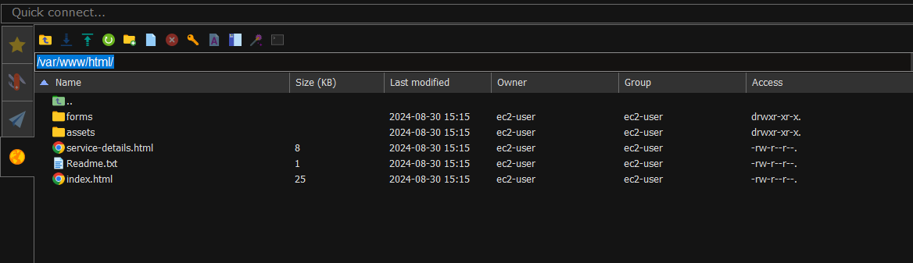

**Activity 5.2 : Configure Web Server Directory and Permissions**

* Verify that the web server points to the correct directory where files are uploaded.
* Set appropriate file permissions: sudo chmod 777 /var/www/html.

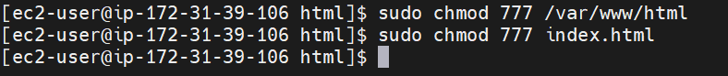

**Milestone 6 : Launching the website**

In this milestone, we launch the website in the ec2 dashboard.

**Activity 6.1:**

* Go to EC2 instance.
* Click on the IPv4 address.
* Website is launched.

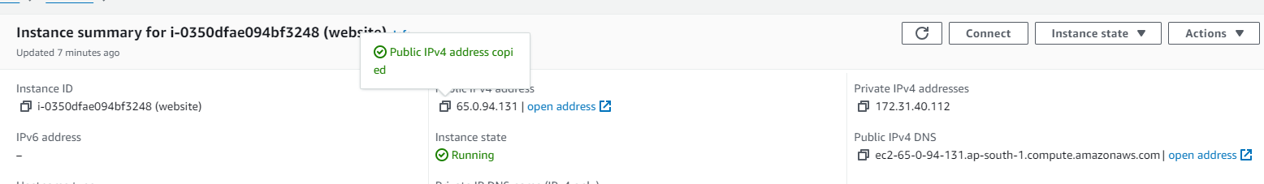

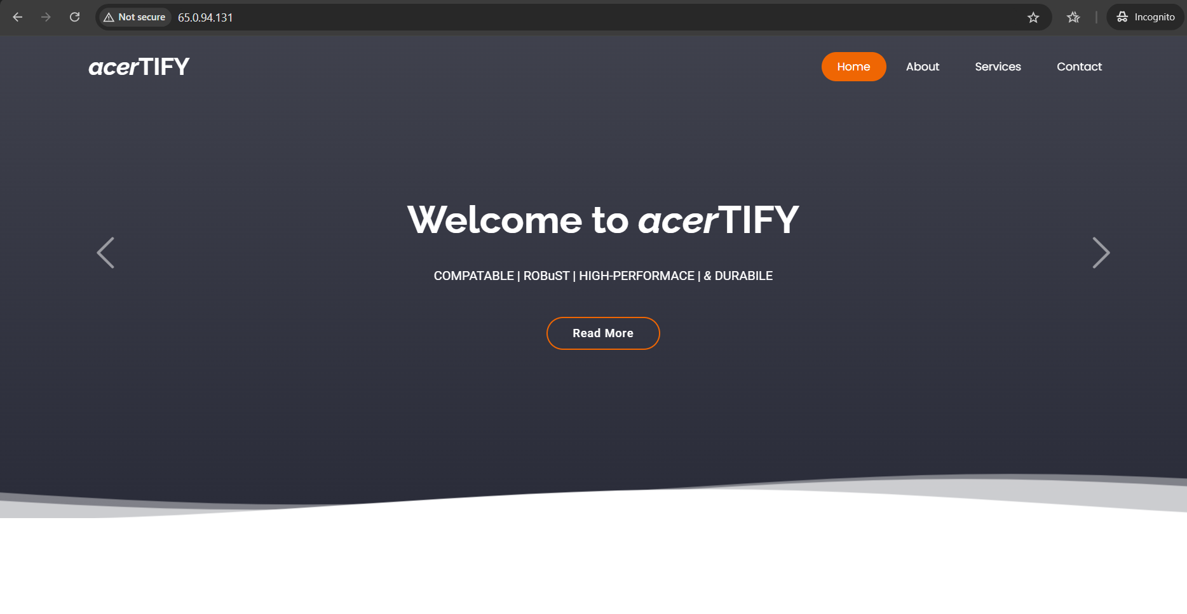

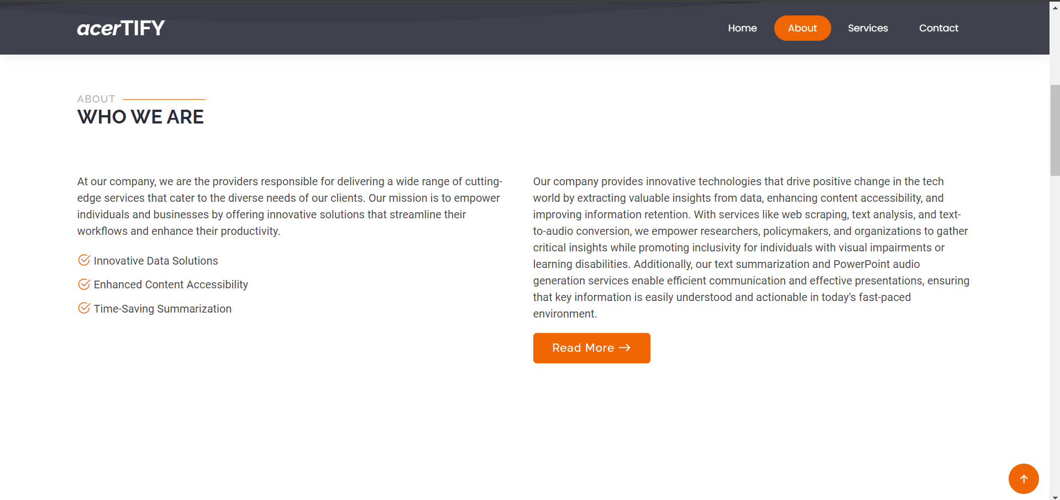

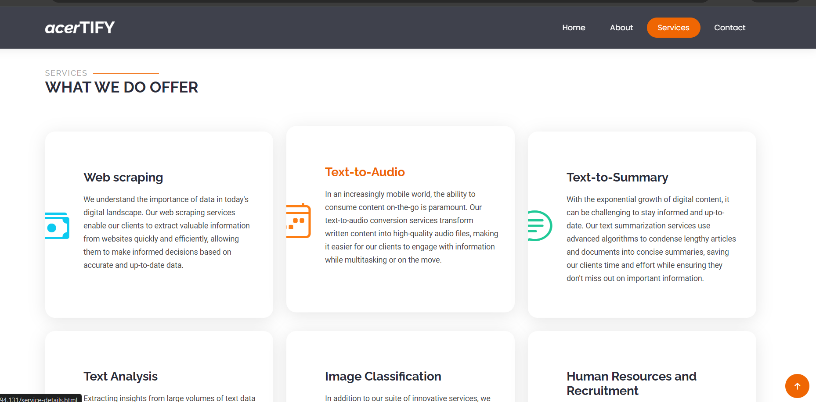

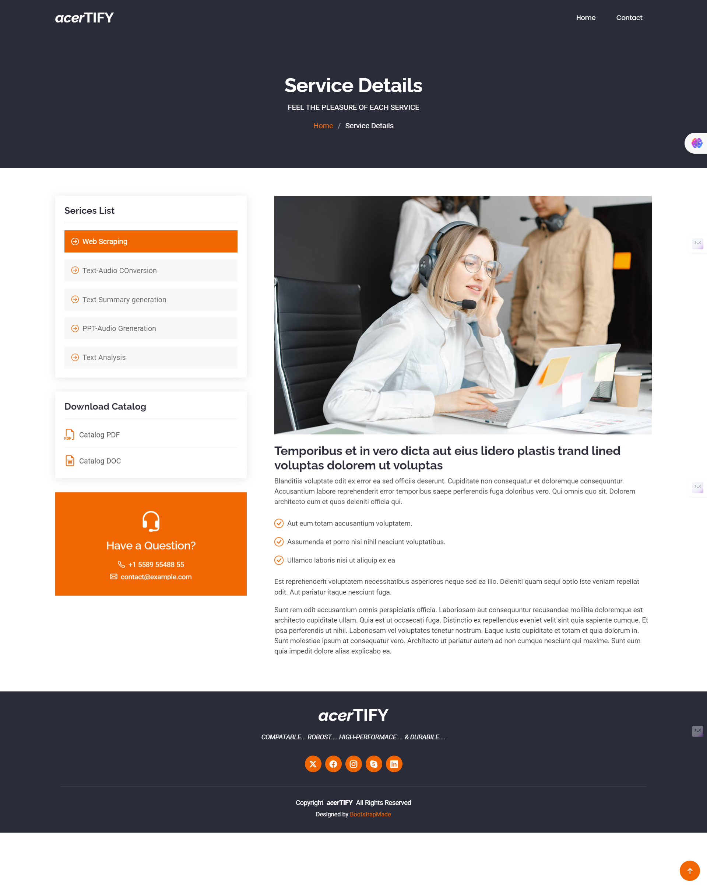

### Milestone 7: Monitor and Optimize Performance

* Performance and efficiency by implementing real-time monitoring with Amazon CloudWatch and proactive alerts.
* It ensures dynamic resource management through Elastic Load Balancing and Auto Scaling, optimizing traffic distribution and resource usage. Additionally, MobaXterm facilitates efficient server management, while Amazon RDS Performance Insights (if applicable) monitors and optimizes database performance.
* These combined strategies deliver a robust, scalable, and cost-effective hosting solution for your organization's entity.

**Conclusion :**

**"Harnessing EC2, VPC, and MobaXterm for Cutting-Edge Entity Hosting"** represents a sophisticated approach to modern web hosting, integrating advanced cloud technologies with efficient management tools. By employing proactive monitoring, dynamic resource allocation, and streamlined server management, this project ensures optimal performance, scalability, and security. This solution not only meets the immediate hosting needs of the organization but also provides a resilient foundation for future growth and innovation.